ELEG 309 - Example Problems Chapter 1-1

**Norton and Thevenin Equivalent Circuits**

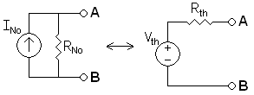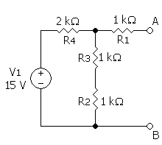

*Vth* = ____________

*Rth* = ____________

*INo*= ____________

*RNo* = ___________



*Vth* = ____________

*Rth* = ____________

*INo*= ____________

*RNo* = ___________



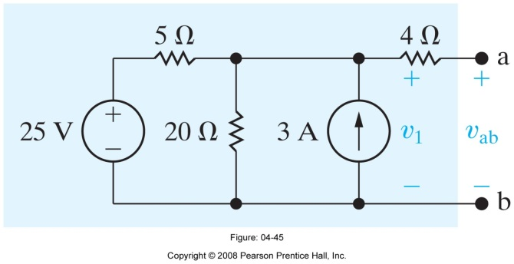

*Vth* = ____________

*Rth* = ____________

*INo*= ____________

*RNo* = ___________

**Example 1.1**

The output resistance of a signal source, although inevitable, is an imperfection that limits the ability of the source to deliver its full signal strength to a load. To see this point more clearly, consider the signal source when connected to a load resistance *RL* as shown in Fig. 1.2. For the case in which the source is represented by its Thévenin equivalent form, find the voltage *vo* that appears across *RL*, and hence the condition that *Rs* must satisfy for *vo* to be close to the value of *vs*. Repeat for the Norton-represented source; in this case finding the current *io* that flows through *RL* and hence the condition that *Rs* must satisfy for *io* to be close to the value of *is*.

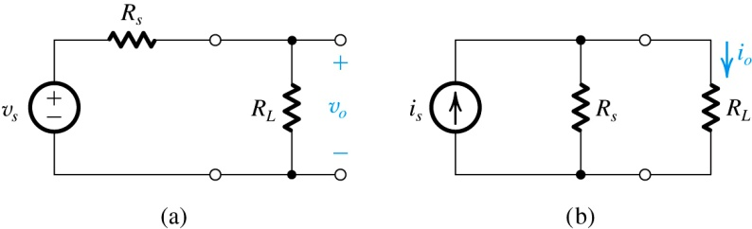

**Figure 1.2** Circuits for Example 1.1.